Sarva Pulla

Samantha Ruggles

GIS Programming for Engineers  
Brigham Young University

Soil Profiler

End User Help File

# Introduction

When looking at a geological site of interest, geologists and geotechnical engineers need to know the properties of the terrain they are looking at. This helps them know what kind of soil they are dealing with and how to make the best use of it. Engineers have a vested interest in the characteristics of the soil because they need to know how much pressure they can place on the ground and what kind of foundation is needed to support a structure. Currently, there are ways to obtain soil information through boring logs. However, this only provides data for specific points and not the extents of the site. This is where the standalone desktop application that we created will be useful. It can interpolate between boring log data and show the user the entirety of the data along a defined cross section at a specific site.

# Purpose

The problem we were presented with was creating a way for a geologist, engineer or other soil enthusiast to input soil profile data from a site and after drawing a cross section on the area, being able to see a graph of all the soil types and their depths along that cross section. In response to this problem, we created a standalone desktop application using DotSpatial and C# that does just that. The easy to use application allows the user to upload a raster of soil data and see exactly what the soil profile will look like along a specified cross section. This will make it simple for users to see what type of soil they are dealing with beneath the surface. Having this information is important to any geologist or engineer wanting to build on or study a certain terrain.

# Obtaining and Installing the Software

The software can easily be obtained and is free to download. It can be retrieved by visiting <https://github.com/SarvaPulla/SoilProfiler> and clicking on the “Download ZIP” button (**Figure 1**). This will provide the software, application and all the supporting files but not any data. Once the ZIP file has been downloaded, it can be unzipped, extracted to a local drive and immediately used. No other software or hardware is needed to use this application. There are no license restrictions. 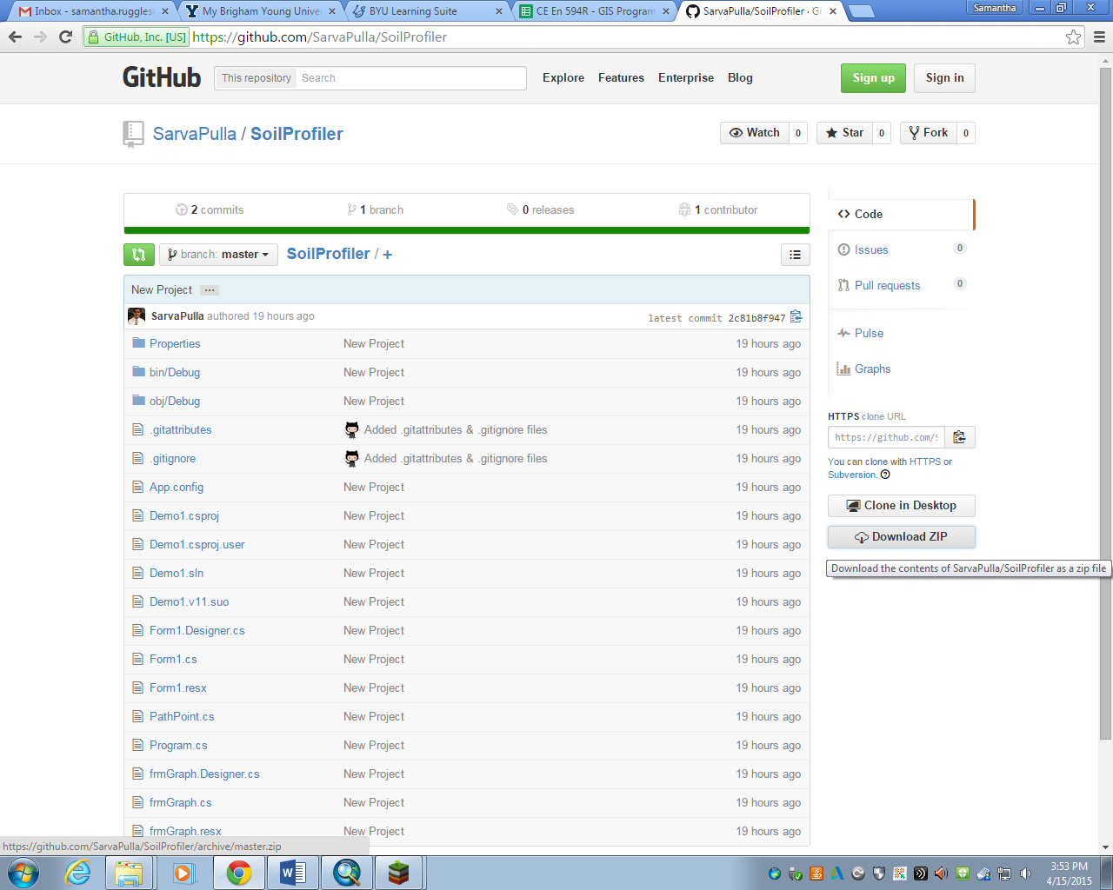

Figure 1. GitHub download

# Input Data

The input data for our purposes was made up in the program ArcMap. We were unable to find any available soil profile data online and this was the best option. To create the data, we simply identified 15 points within a square mile in Utah County and created a shapefile of them. We then added soil types and depths to the attribute table to give each point a profile, similar to a boring log. After each point had data, the “Krigging” tool was used in ArcMap to interpolate a soil profile across the entire site. This tool took the individual points and their soil data as input and created a raster of soil types and depths as an output. There were 5 different types of soil in our profile which created 5 distinct rasters and files. These files needed to be saved as a TIF, which is the type of file that the application will read. If the user wants to, they can do this same process in ArcMap with real boring log data. They will need to create their own shapefile based on actual locations of boring holes and manually enter in the depths of the soil types at those locations. However, if the user has access to a raster containing soil information, that would work as well.

# Starting and Running the Software

As mentioned previously, the application can easily be started and run after the ZIP file has been unzipped and downloaded to a local drive. Following this file path will take the user to the executable application: SoilProfiler-master\bin\Debug. Within the Debug folder, opening the file “Demo1” will open and start the application as seen in **Figure 2**.

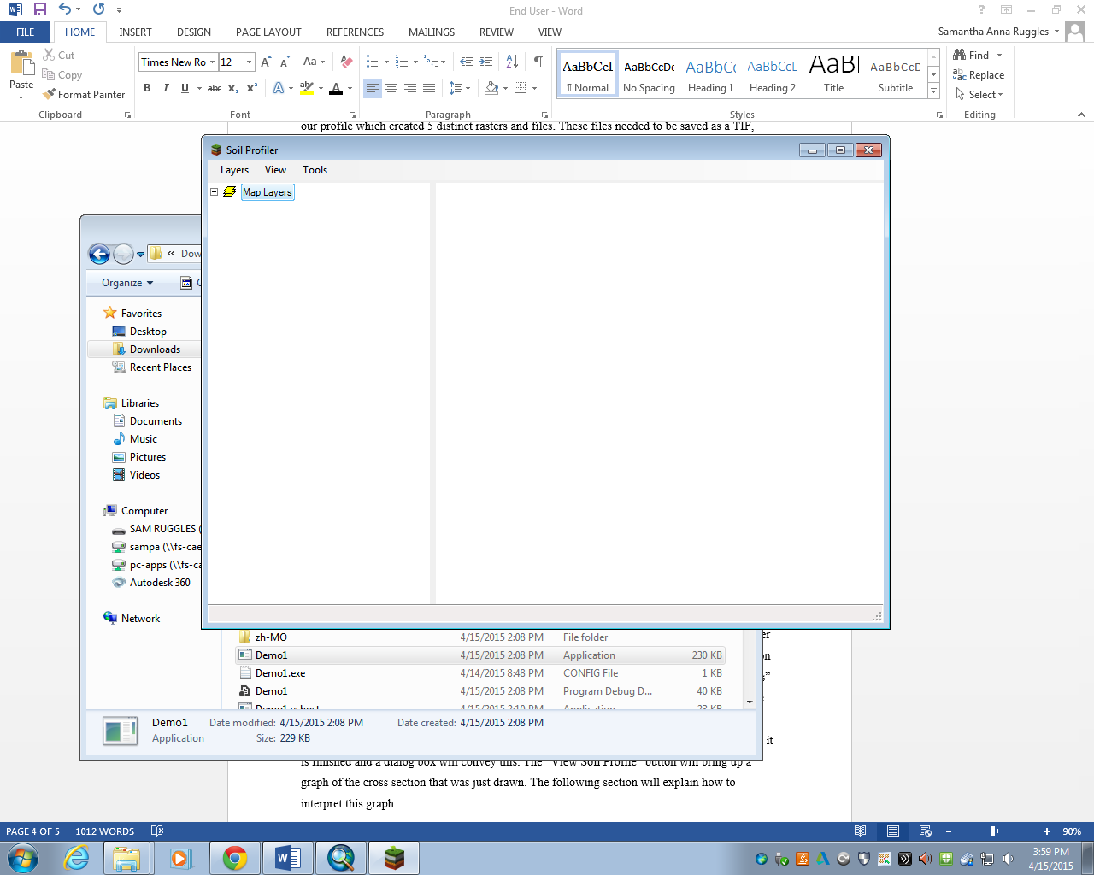

Figure 2. SoilProfiler application

Once the app is open, it is very easy to use. The toolbar along the top provides simple tools to navigate through the process of inputting and interpreting soil data. First, the data will be uploaded by clicking on the “Layers”, then the “Add Raster Layer” buttons. This will pull up a file explorer from which the raster data can be navigated to and opened up. After one or more raster layers have been uploaded, they will appear in the map on the right and a legend will display on the left where the layers can be toggled on and off (**Figure 3**). The map can be zoomed in and out by clicking on the “View” tab. Under the “Tools” tab, the user will find the “Draw Line” and “View Soil Profile” buttons. The former allows the user to draw a cross section anywhere within the raster and a dialog box will pop up with instructions on how to start and end the line. The line shapefile will automatically be saved once it is finished and a dialog box will convey this. The “View Soil Profile” button will bring up a graph of the cross section that was just drawn. The following section will explain how to interpret this graph.

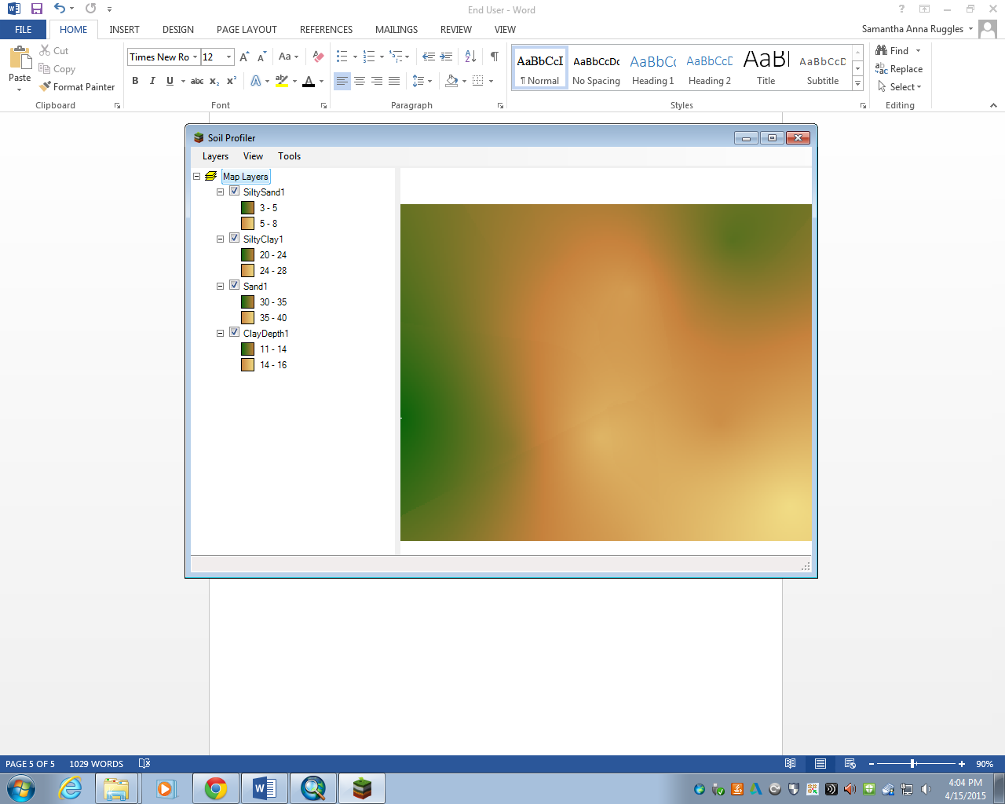

Figure 3. Application with rasters loaded and displayed on the map

# Interpretation of the Application

The end result of this application is a graph of a soil profile created from a user defined cross section. The cross section is created by drawing a line on the imported soil raster data. The graph can be accessed by clicking on the “View Soil Profile” button located under the “Tools” tab on the main application screen. The graph will show a line for each layer of soil that was imported (**Figure 4**). This line will display the depth of the layer, in meters, at a certain distance along the cross section. If there are multiple layers, they will each be displayed and identified in the legend above the graph. Using this simple application will give a clear representation of the soil layers and their depths under the ground, making it easy for anyone to have soil information about a site.

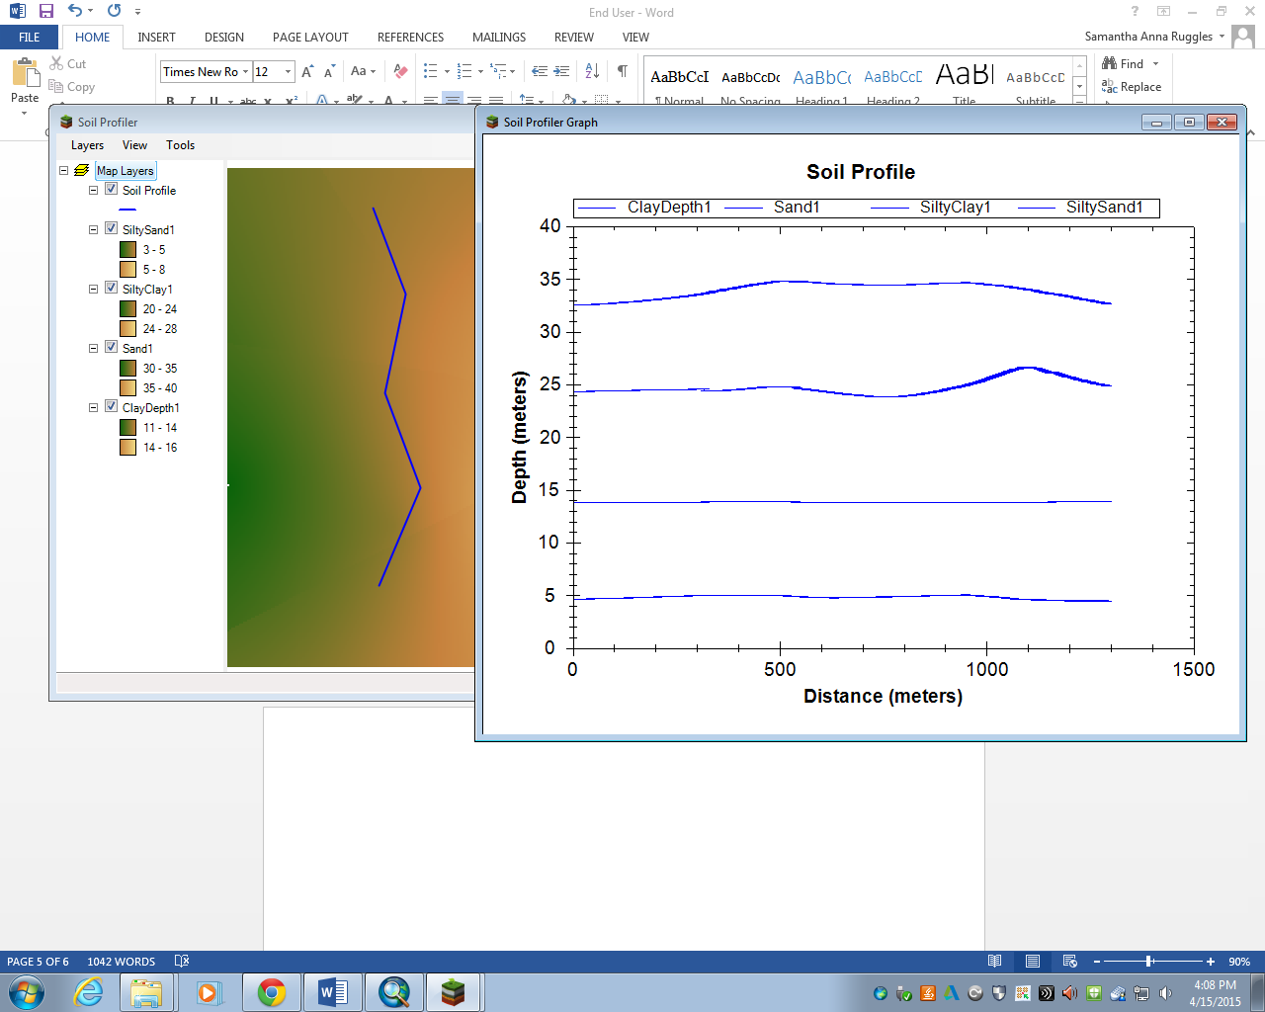

Figure 4. Cross section and graph of the soil profile